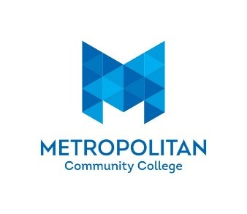

Construction Career Day – Spring 2019
Metropolitan Community College, Fort Omaha Campus, Construction Education Center
April 18, 2019

7:30 AM – 8:30 AM – Industry Check In
Building 25—Construction Education Center, Room 112/114

8:30 AM – 9:00 AM – Students Check In/Welcome/Grouping
Building 24—Center for Advanced and Emerging Technology

9:00 AM – 9:40 AM – First Rotation

9:40 AM – 10:20 AM – Second Rotation

10:20 AM – 11:00 AM – Third Rotation

11:00 AM – 12:00 PM – Lunch Break (lunch provided); Kayleen McCabe to speak
Building 24—Center for Advanced and Emerging Technology

12:00 PM – 12:40 PM – Fourth Rotation

12:40 PM – 1:20 PM – Fifth Rotation

1:20 PM – 2:00 PM – Sixth Rotation

2:00 PM – 2:10 PM – Closing

